Love Without Limits By Elyte Alliance

🌟 Join Us for Our Monthly Special Needs Speed Dating Event! 🌟
❤️ Love Knows No Boundaries ❤️

📆 Date: Friday 25th November + more dates to follow
🕒 Time: 6pm to 9pm
📍 Location: Elyte Hub – 1/10 Olympic Circuit, Southport
🌈 Inclusivity, Connection, and Love for All 🌈
💞 Are you ready to make meaningful connections in a warm and inclusive setting? 💞
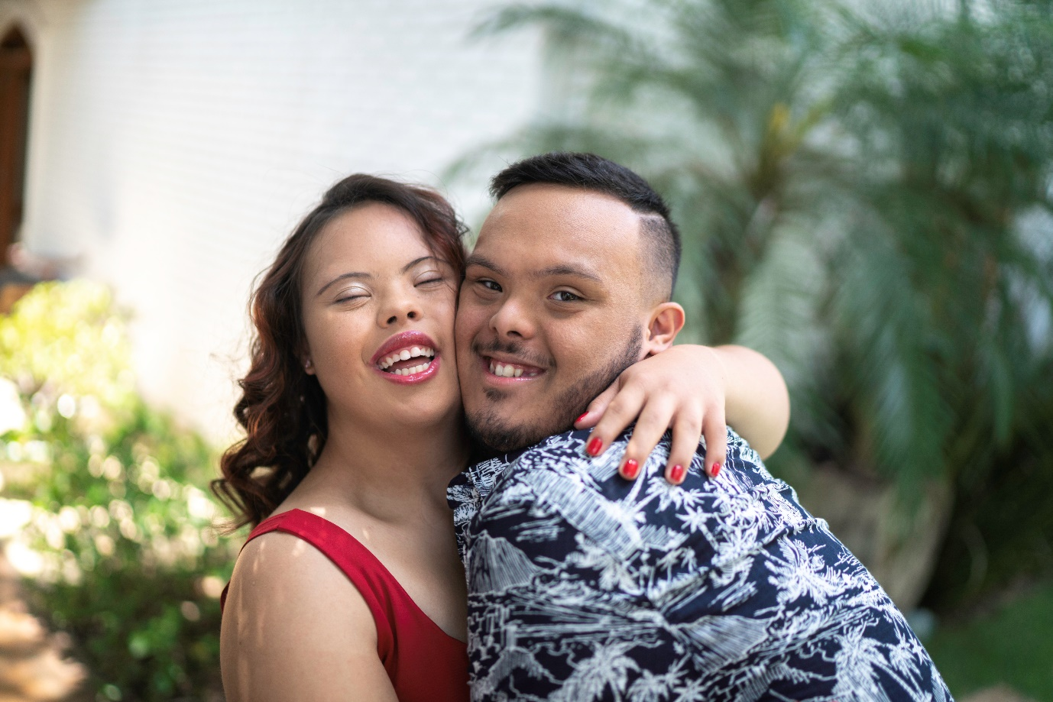
🌟 What to Expect 🌟
🥂 Speed dating rounds designed for special needs.
🗨️ Guided by experienced and caring volunteers.
🌆 A sensory-friendly and accessible venue.
🙋‍♂️🙋‍♀️ Opportunities to meet incredible people.
🥰 Potential for friendships, romance, and more.
🎁 Free snacks and refreshments provided.

📋 Register Now! 📋
Visit [Event Website] to register and find more information. Limited spots available, so don't miss out!

🤝 We're All About Inclusivity 🤝
Our event welcomes individuals with autism, Down syndrome, and various special needs. We create a compassionate and supportive space for everyone to connect and celebrate love.

📣 Share the Love 📣
Help us spread the word by sharing this event with friends, families, and your community. Together, we can make a difference and create beautiful connections.

📧 Questions? Contact Us 📧
If you have any questions or need assistance with registration, feel free to reach out to us at
Email: intake@elyte.com.au
Phone: 1800828585.

Let's come together, embrace diversity, and create memorable moments. Join us for an extraordinary evening of connection and love!

🌟 We can't wait to see you there! 🌟
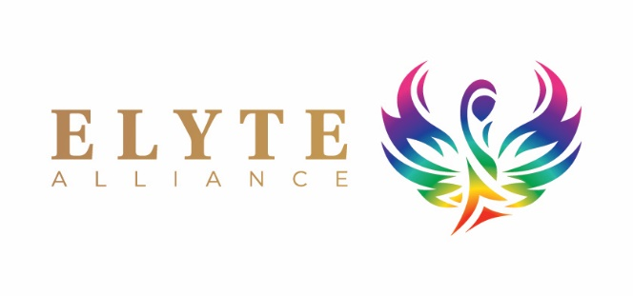

#SpecialNeedsSpeedDating #InclusiveLove #ConnectionMatters #SpreadTheLove

